Creating the Find Method
Accessing the Database with your code

Creating the Data Layer 1
Start your Git Hub day 1
Before you Begin 1
Modifying the Find Function 1
Connecting to the Database 3
clsDataConnection 3
SQL Connect 4
Connection Strings and Public Git Repositories 4
Creating the Test Record 4
Merge the Branch to the Master 5

Creating the Data Layer

Start your Git Hub day
(As always start in a fresh branch)

Before you Begin
Make sure that you have completed the work for last week and that you have watched the eLectures for this week before starting this work.

At this stage all tests should pass, however there is still one important feature that is missing.
That is, we are still not actually drawing the data from the database!
You will have created the table we need the other week…
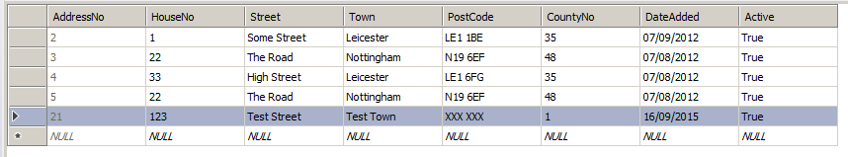
You will also need to create the following stored procedure…
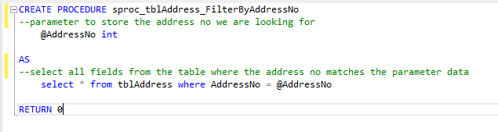
Once you have set these up, I would suggest you test the stored procedure to make sure that it works as planned. Use the SQL server object explorer to execute the stored procedure directly.
Make sure it is working before you go onto the next steps.

Modifying the Find Function
We now need to change the code for the Find method from this…
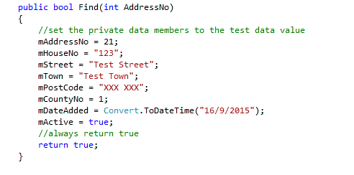
To this…
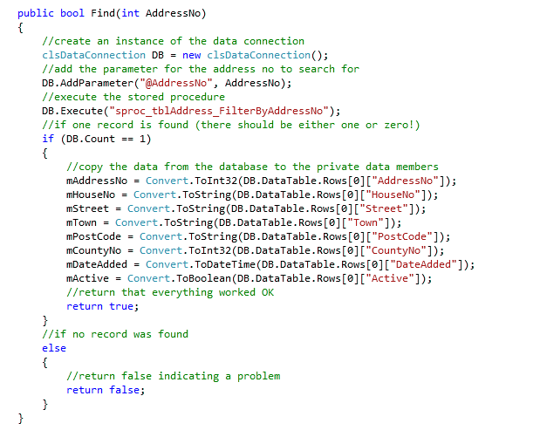
You should now see all your lovely tests fail, so what is the problem?
The problem is that our find method is looking to connect to the database, and we need to set up a few things to allow that to happen.

Connecting to the Database
There are several ways that we can connect to the database in this work.
The first approach is to use the online SQL Teams portal, we did that the other week.
The next approach is to use Visual Studio to create tables and stored procedures. We did that just now.
The final tools are the class clsDataConnnection and SQL Connect which allow our running program to access SQL Server directly.

clsDataConnection
This class has been written for you to avoid you having to deal with the complexities of working with ADO.NET the technology used by Microsoft to link to the SQL server database.
When you created your skeleton system, you will have followed the instructions for adding this class to your class library.
Notice in the following code how the object DB is used to manipulate the stored procedure and access the fields in the table…

SQL Connect
The last tool we need to use is a little program called SQL Connect. For your code to connect to SQL Server we need to provide it with the name of your server, then the name of your database, your username and password.

Connection Strings and Public Git Repositories
A connection string is a string containing authentication and other settings to connect to the database.
The connection string will need to contain your username and password for the SQL server database.
So, here is the problem. If you add the connection string into your code and place it into a public repository, your plain text username and password is visible for all to see.
Even if you were using a private repository it likely still isn’t a good idea to store these details as plain text.
To get around this problem a program has been written called SQL Connect, available from the module web site.
When you run the program, you will see the following interface...
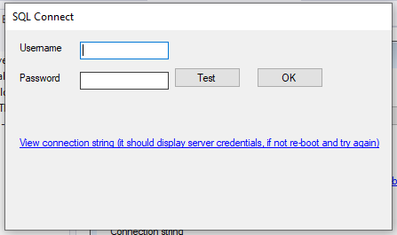
SQL Connect must be running at the same time as your program to allow your code to access the database.

Creating the Test Record
Even with all of this in place you will still find that your tests are still failing, why?
The problem is that all our tests are looking for a record 21, does such a record exist?
The answer is likely a no!
So, what is the problem?
Clearly, we need to ensure that the test data we are using exists.
You will need to match up the record ID in the tests to a record that actually exists, also you will need to set up test data in that record matching the test data you are looking for in the same test.
Do not carry on to the next section until all your tests are green!
Once you have all your tests running green you can be 100% sure that your code for finding records is working perfectly.

Merge the Branch to the Master
The changes to your code may be minor but they will still need merging to the master repository and the unwanted branch needs to be removed.

